**Q2. Manually configure static routes on a router to direct packets to different subnets.Use the ip route command and verify connectivity using ping and traceroute.**

**Network setup:**

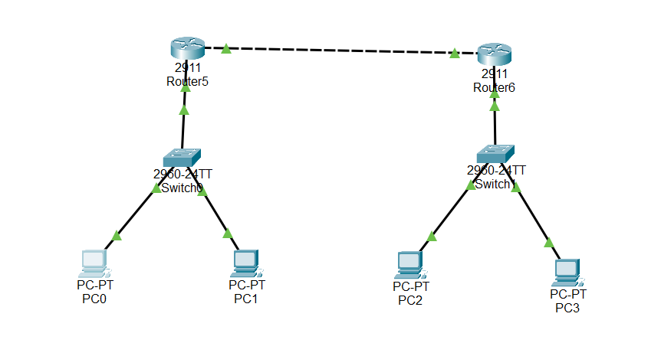

**Configuring router-5:**

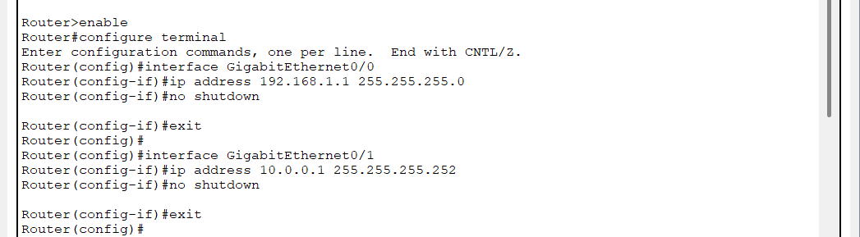

**Configure Static Route to 192.168.2.0/24 via Router6:**

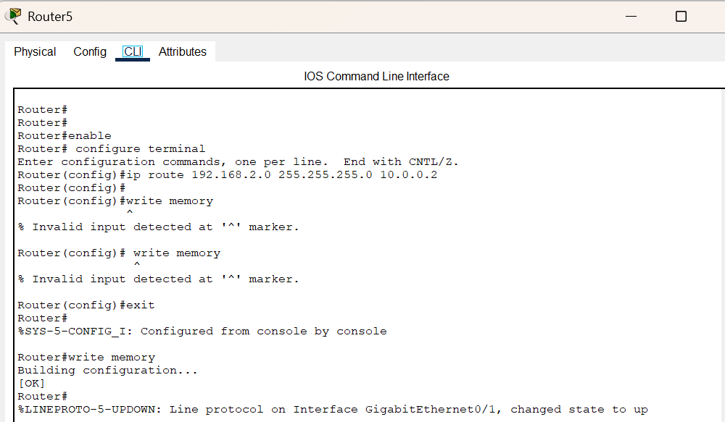

**Configuring router-6:**

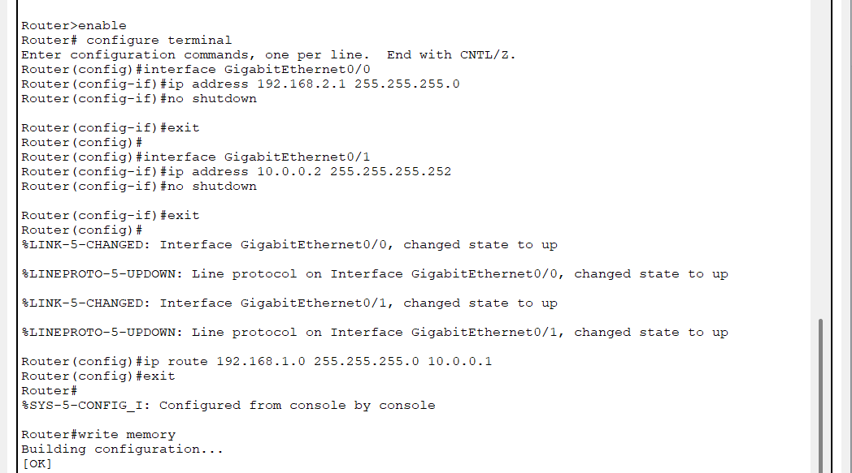

**Configure Static Route to 192.168.1.0/24 via Router5:**

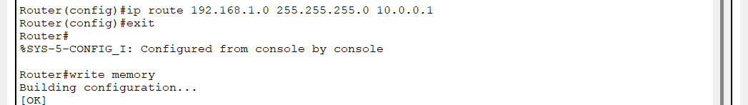

**From PC0, pinging to PC2:**

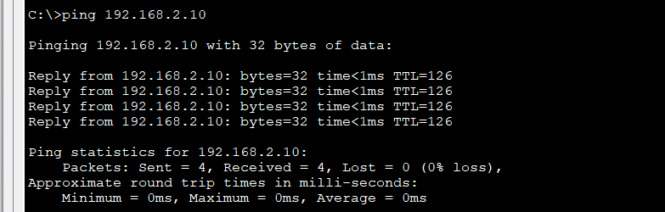

**On Router5, checking the routing table:**

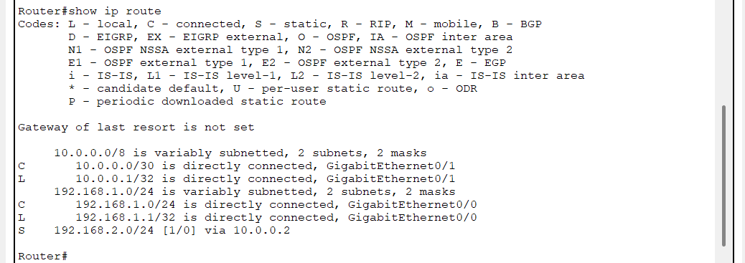

On **Router6**, check the routing table:

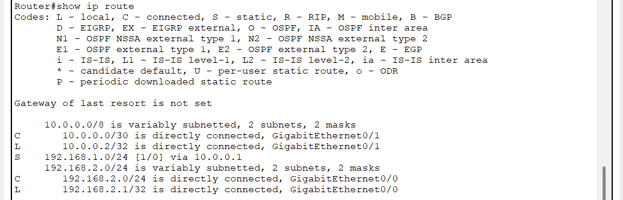

**From PC0, checking the path to PC2 , using tracert :**

